**Feasibility analysis of Face Polygon**

Review of NIIT University students who are the target customers of our app. Feasibility analysis over the validiation of idea and percentage of people who are willing to utilize this service. We got the following feedback

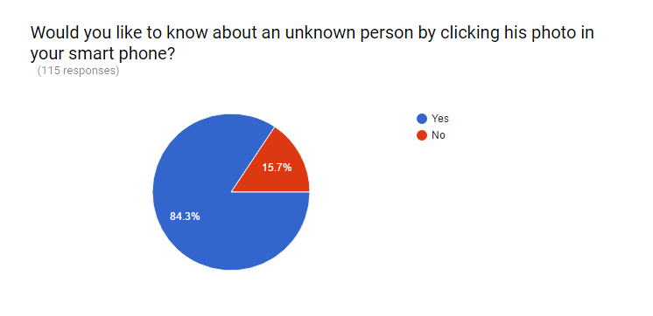

97 responses YES

18 responses NO

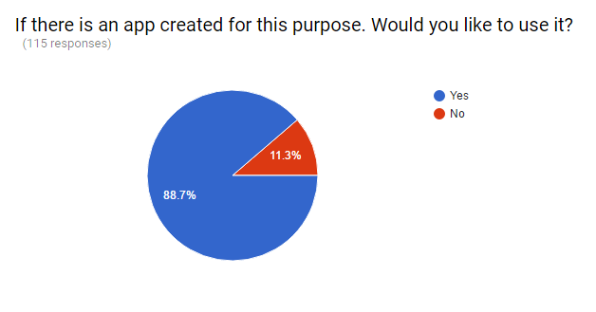

102 responses YES

13 responses NO

With all the responses we have received we can conclude that our idea of creating a new kind of social app Face Polygon is feasible and we can proceed further in the process of software development.